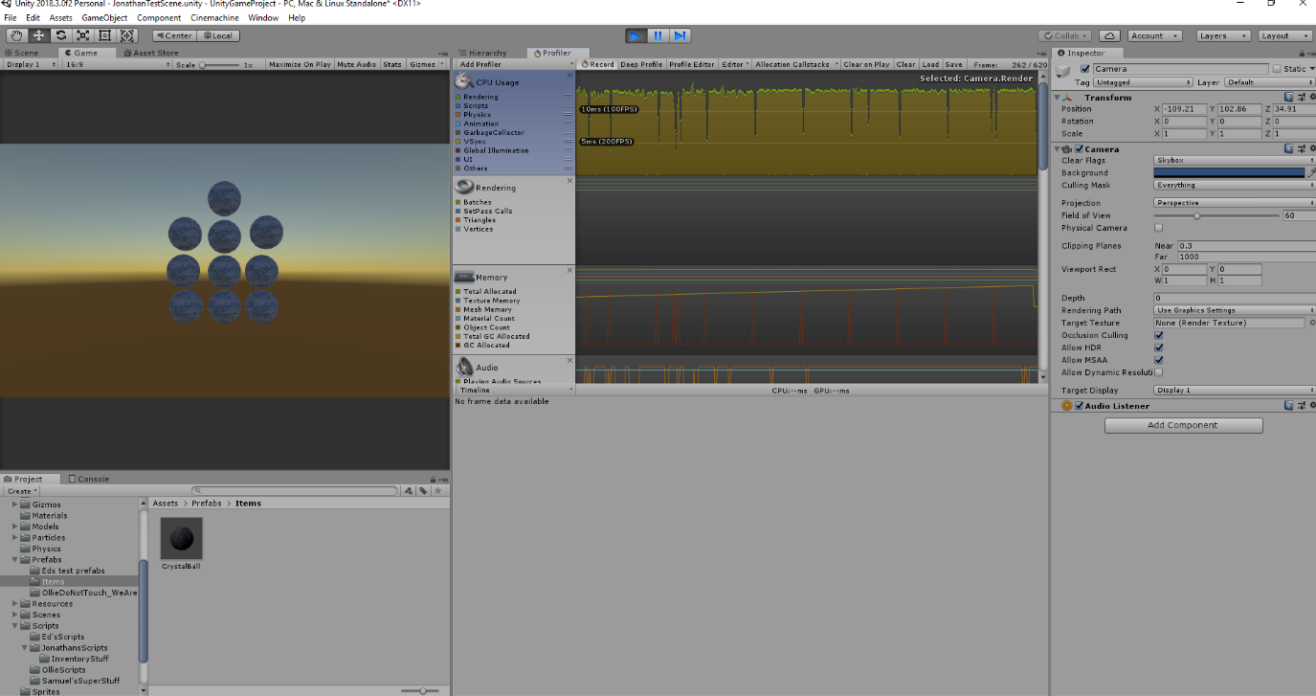Crystal Ball stress test

With 10 crystal balls the game is already showing a little performance hit. This is mostly because of the material on the crystal ball which is while testing it.

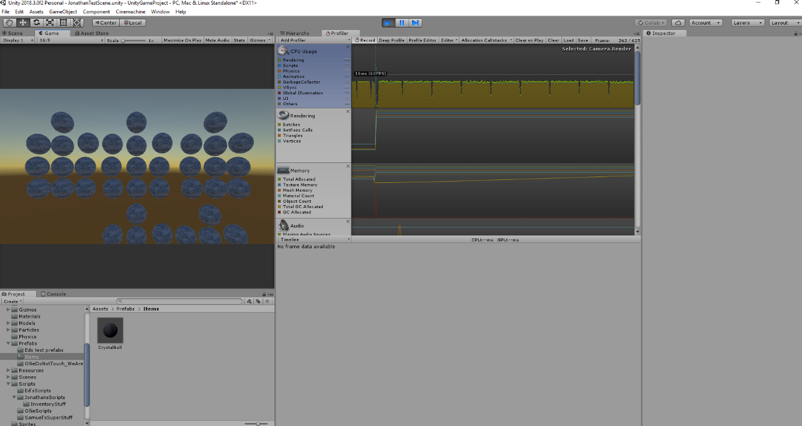

At 50 crystal balls the game has a lag spike on load equivalent to around 1,000 house meshes from the previous test. This suggests I won’t get to 10,000 crystal balls with the current performance.

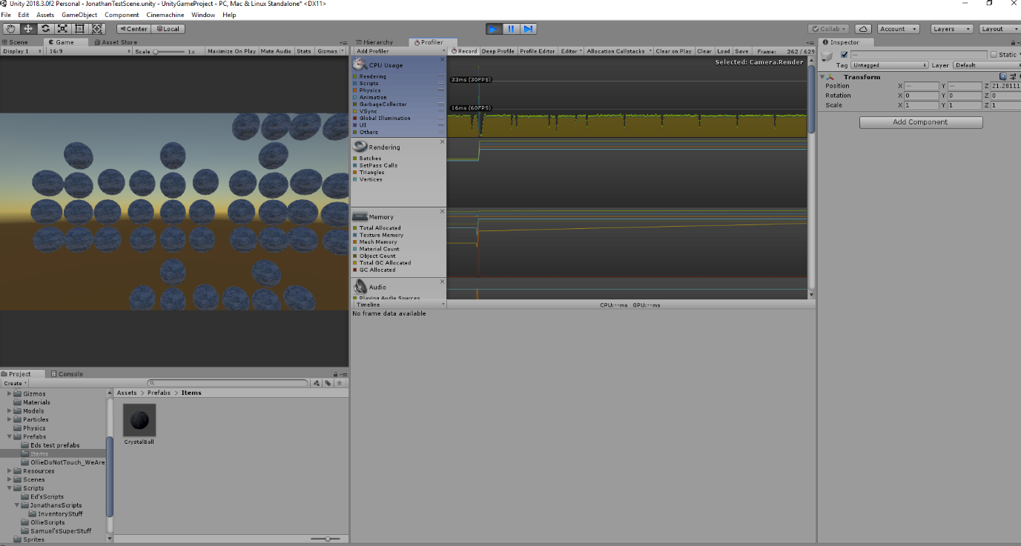

At 100 crystal balls the drop still keeps 60fps performance but is not encouraging for 1,000

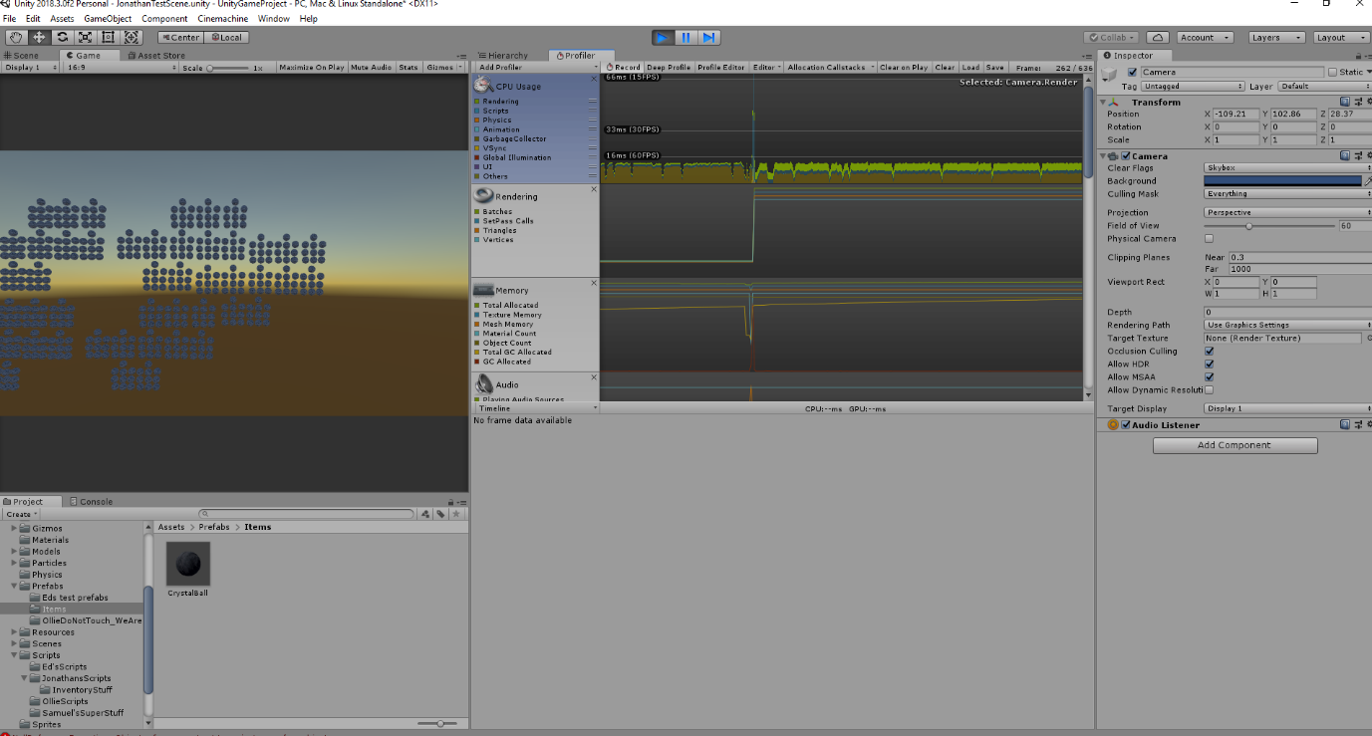

At 500 its working, but not amazingly. Trying 1,000 next.

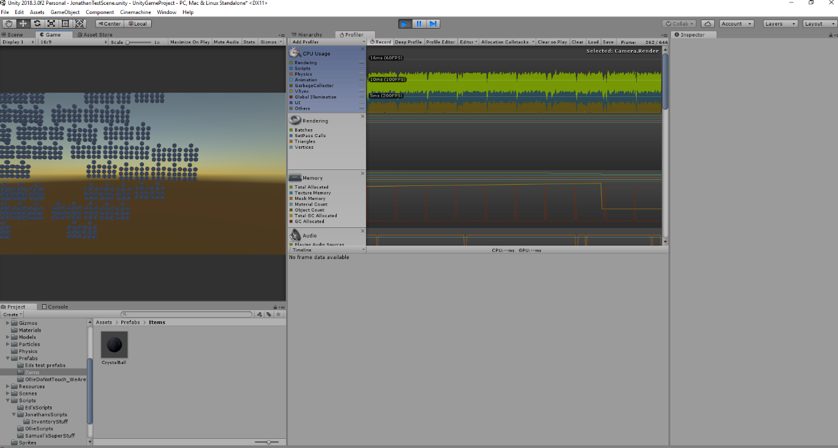

At 1,000 the game performance has clearly shown that this asset is pretty much split into 3 parts. Rendering, Physics, Garbage. Finally I’m going to go for 10,000 to see if it just stabilised instantly.

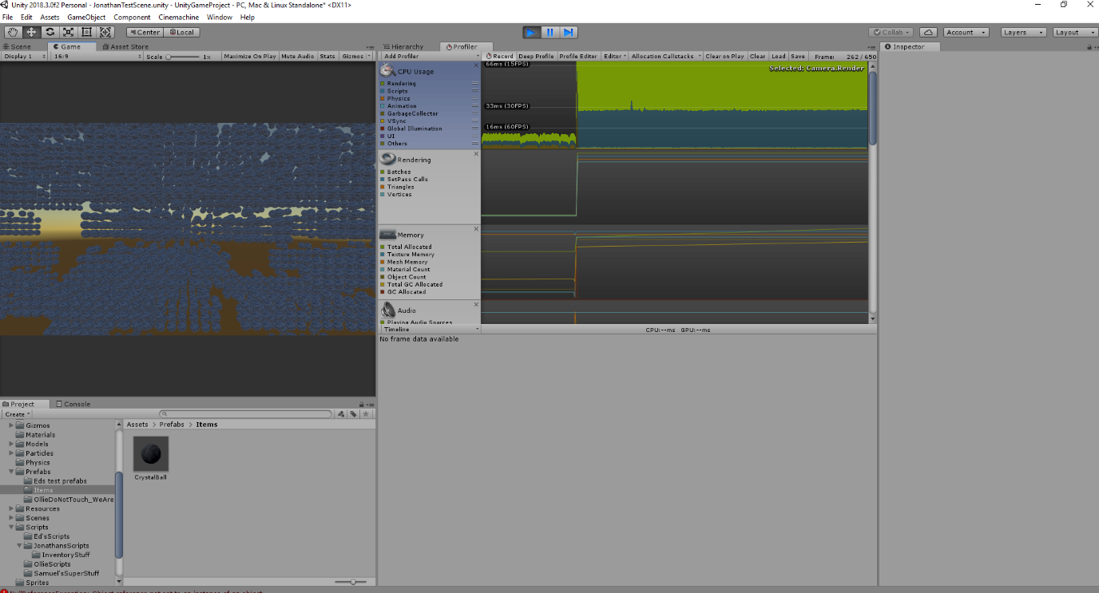

Once again, at 10,000 crystal balls the system has maxed out. It’s still stable but at a much lower FPS. So I’m happy with the models optimization and that fact that several can be in a scene without problems.